
Comsats University Islamabad
(Vehari Campus)

Submitted by: Naveed Abbas
& Zubair Azhar

Submitted to: Ma’am Yasmeen Jana

Registration No: FA22-BSE-109
& FA22-BSE-108

Subject: Advanced web technologies

Topic: Assignment # 3

Signup:
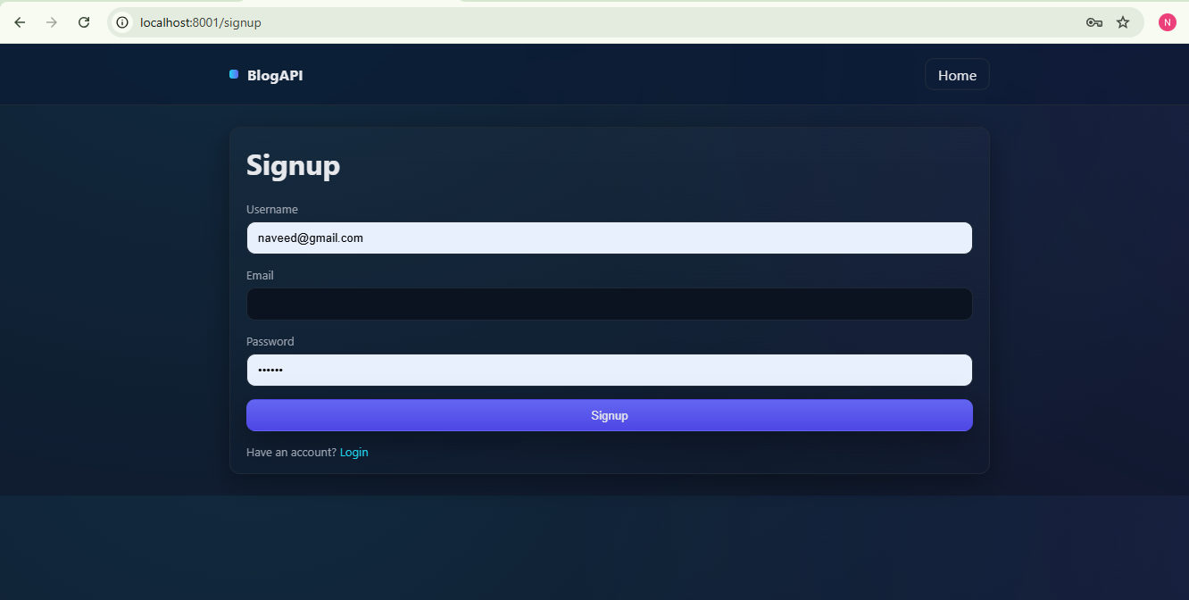

login:
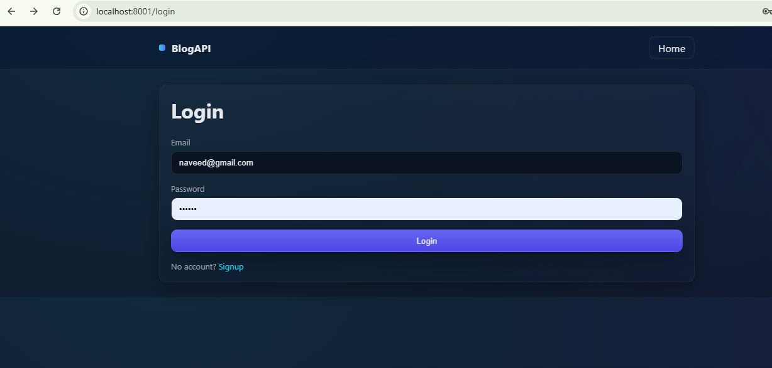

Home:
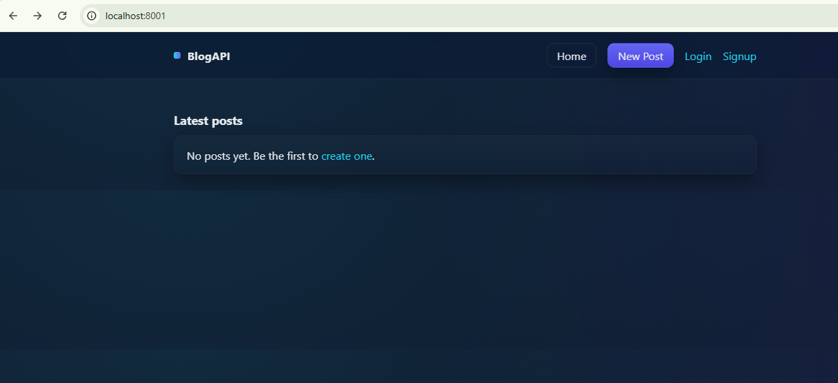

Posts:
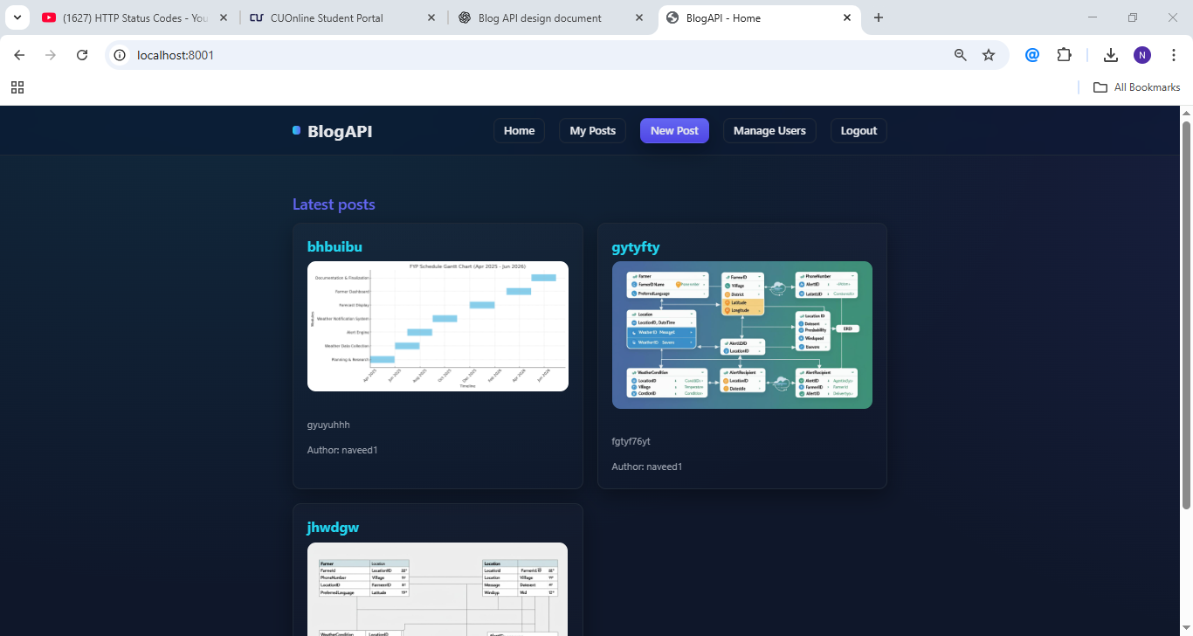

Admin management:
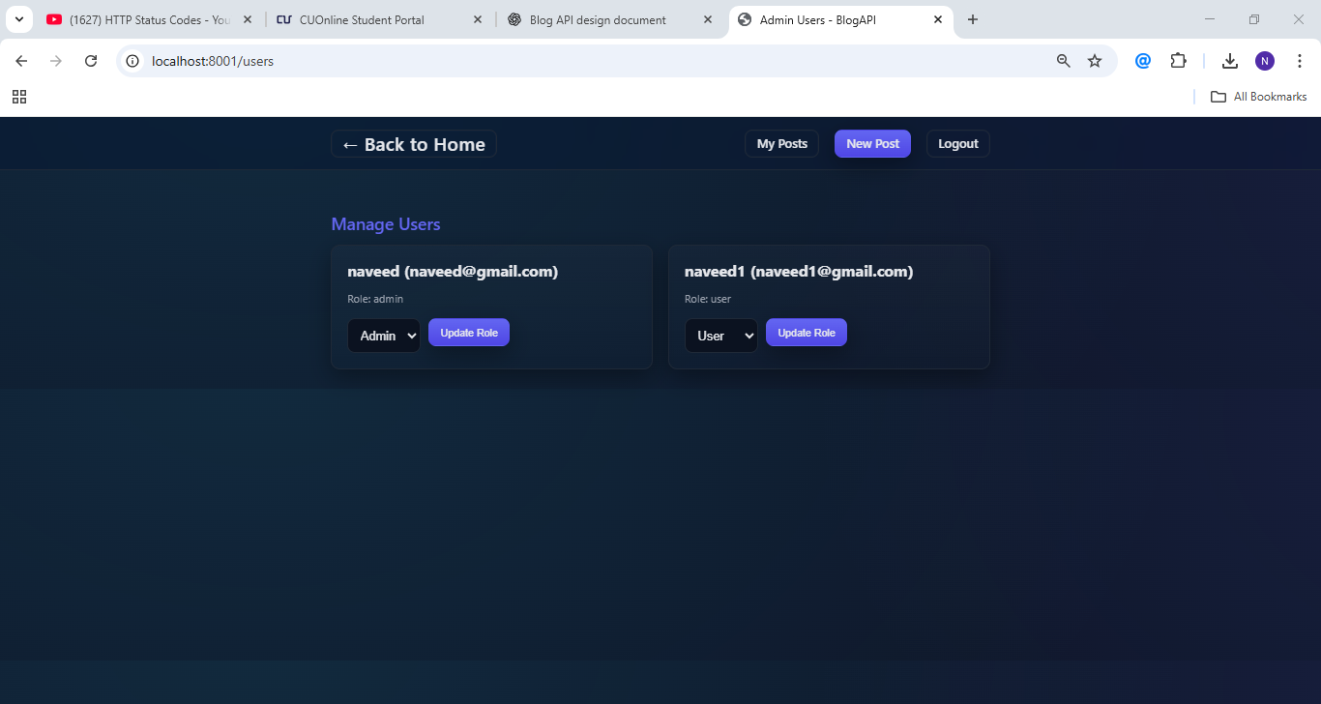

Codes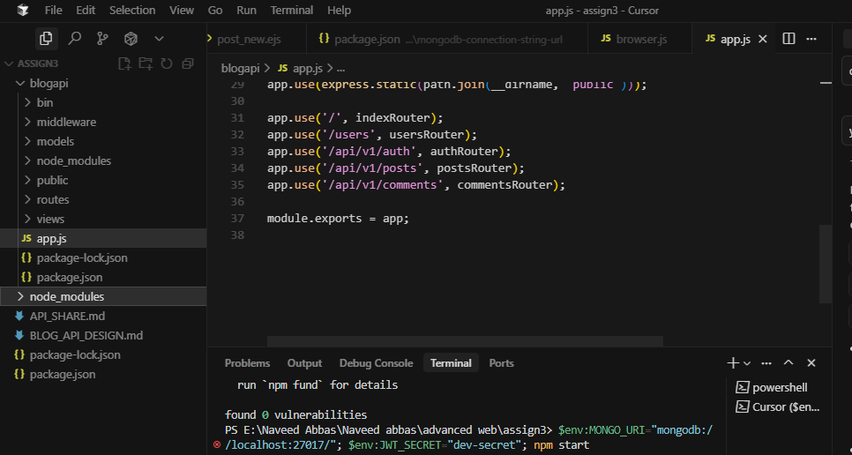

Internal model view routes:
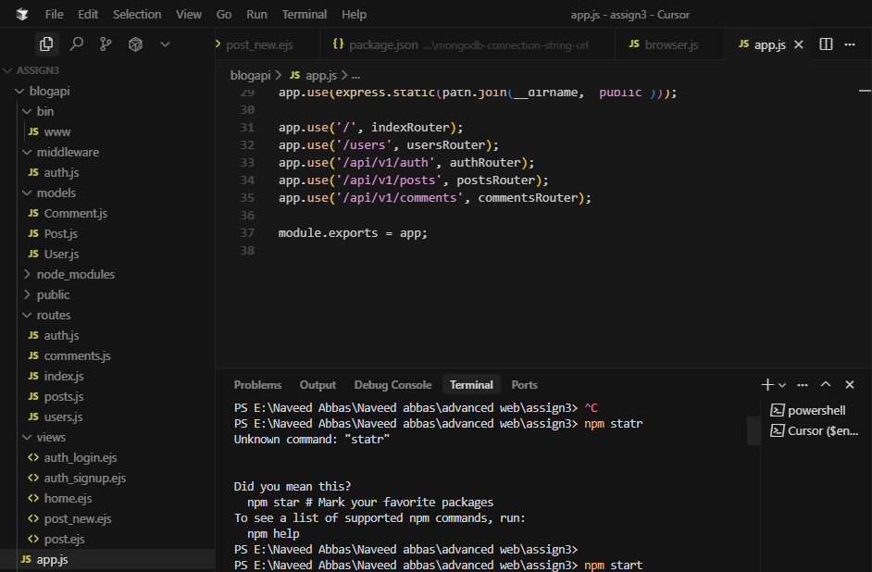

MongoDB server:
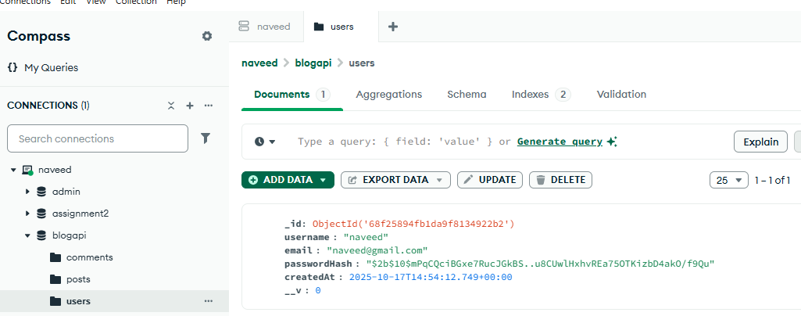

BLOG API DESIGN — FULL-STACK APPLICATION OVERVIEW

This document outlines the current state and features of the full-stack Blog Application built with Node.js, Express, and MongoDB, following an MVC architecture.

1. Principles followed
- MVC Architecture: Separation of concerns with models, views, and controllers (routes).
- RESTful-ish API: Routes are defined directly for UI interaction (e.g., /auth/login, /posts/new).
- JSON for API responses (where applicable for future API extensions).
- Use standard HTTP status codes.
- Security best practices for authentication and data handling.

2. Main resources & relationships
- User
- Attributes: `_id`, `username`, `email`, `password` (hashed), `role` (`user`, `admin`), `createdAt`, `updatedAt`.
- Relationships: Has many Posts, has many Comments.
- Post
- Attributes: `_id`, `title`, `content`, `author` (User ref), `image` (path to image), `likes` (array of User refs), `dislikes` (array of User refs), `createdAt`, `updatedAt`.
- Relationships: Belongs to User (author), has many Comments.
- Comment
- Attributes: `_id`, `content`, `author` (User ref), `post` (Post ref), `createdAt`, `updatedAt`.
- Relationships: Belongs to Post, Belongs to User.

3. URI design (implemented examples for the full-stack application)
Base: / (No API version prefix for EJS views-based routes)

- Authentication
- `GET /auth/signup` -> Render signup form
- `POST /auth/signup` -> Register new user
- `GET /auth/login` -> Render login form
- `POST /auth/login` -> Authenticate user
- `GET /auth/logout` -> Logout user

- Posts
- `GET /` -> List all posts on the homepage (populates author)
- `GET /posts/new` -> Render new post creation form (auth required)
- `POST /posts/new` -> Create new post (auth required, with image upload)
- `GET /posts/:id` -> Display single post (populates author and comments)
- `GET /posts/:id/edit` -> Render edit post form (auth required, owner only)
- `POST /posts/:id/edit` -> Update post (auth required, owner only, with optional new image upload)
- `POST /posts/:id/delete` -> Delete post (auth required, owner only)
- `POST /posts/:id/like` -> Like/unlike a post (auth required)
- `POST /posts/:id/dislike` -> Dislike/undislike a post (auth required)

- Comments
- `POST /comments/:postId` -> Add a comment to a post (auth required)
- `POST /comments/:id/delete` -> Delete a comment (auth required, owner only)

- Users
- `GET /users` -> List all users (JSON response)
- GET /users/myposts -> Display posts created by the logged-in user (auth required)

4. HTTP methods & semantics (mapping)
- GET: read-only (200 OK, or redirect)
- POST: create or action (201 Created, or redirect)
- DELETE: delete (redirect)

5. Query parameters & common conventions
- Not extensively used for display routes; primarily focused on direct form submissions and redirects.

6. Error handling format
- Server-side errors and validation messages are passed to EJS templates and displayed to the user using `connect-flash` and `express-validator`.
- General server errors log to console and render a generic error page.

7. Security strategy (brief)
- HTTPS/TLS: Assumed to be handled by deployment environment.
- User Authentication: Implemented using `express-session` for session management and `bcryptjs` for secure password hashing.
- Server-side Input Validation: `express-validator` is used for robust validation on signup and login forms.
- Image Validation: Custom middleware (`imageUpload.js`) validates uploaded image types and sizes.
- Access Control: Middleware (`auth.js`) restricts access to authenticated users and implements role-based restrictions (though only `user` role is currently active).
- Proper Session Handling: `express-session` with `connect-mongo` for persistent sessions.

8. Current Features & Implementation Status
The application is a full-stack Blog Application built with Node.js, Express, and MongoDB (Mongoose), following an MVC architecture.

Implemented Features:
- User Authentication:
- User registration and login using `express-session` and `bcryptjs` for password encryption.
- Input validation on registration and login forms using `express-validator`.
- Display of validation and general error/success messages using `connect-flash`.
- Blog Management (CRUD):
- Create: Users can create new blog posts with a title, content, and optional image upload (`express-fileupload`).
- Read:
- Homepage displays a list of all posts with truncated content and author information.
- Individual post pages display full content, image, author, and comments.
- "My Posts" dashboard allows logged-in users to view only their own posts.
- Update: Users can edit their own posts (title, content, and optionally update the image).
- Delete: Users can delete their own posts.
- Comments:
- Logged-in users can add comments to any post.
- Comments are displayed with author and timestamp.
- Users can delete their own comments.
- Like/Dislike Functionality:
- Authenticated users can like or dislike posts.
- Like/dislike actions toggle (clicking again removes the previous action).
- Counts of likes and dislikes are displayed on individual post pages.
- Middleware:
- Request logging middleware (`logger.js`) for every incoming request.
- Authentication middleware (`auth.js`) to restrict access to authenticated users and (placeholder for) role-based access.
- Image upload validation middleware (`imageUpload.js`).
- Database Design: Mongoose schemas for `User`, `Post`, and `Comment` with appropriate validations and relationships (`.populate()` demonstrated).
- User Interface: Enhanced styling with improved typography, card designs, buttons, subtle animations, and responsive adjustments for a more visually appealing and user-friendly experience. A basic `layout.ejs` (now removed, but its structure integrated into individual views) ensures a consistent header and footer.

Pending Features (from original request):
- **WYSIWYG Editor for Content Creation:** This feature was part of the initial request but has not yet been implemented. Currently, a standard `<textarea>` is used for post content.
- **Admin Role Management:** While the `role` field exists in the User schema and `restrictToAdmin` middleware is present, explicit routes/UI for admin management are not yet built.

To Run the Application:
1. Ensure MongoDB is running.
2. In your terminal, navigate to the project root (`E:\Naveed Abbas\Naveed abbas\advanced web\assign3`).
3. Install dependencies: npm install`
4. Start the server (with auto-restart on changes): npm run dev`
5. Access the application in your browser at `http://localhost:3000`.

